Algebra Passport

Name: ________________________________________
House: ________________________________________

Completed on: ________________________________

Signed: _______________________________________

Core Skills 1
Collecting like terms
1. a + 2a + a =
2. a + b + a + b =
3. 3a + b + a =
4. 5a – b – a + 2b =
5. x + x + 2y – x =
6. x² + 3x²=
7. 2xy + xy =
8. 4xy – xy + 3a =
9. 6ab + b + ab + 3b =
10. a + b – a + b – a – 2b =

Checked

Core Skills 2
Multiplying terms
1. 3 × 4a =
2. 5 × 5c =
3. 4f × 6 =
4. 2a × 3b =
5. 7b × 2d =
6. 2a × 3a =
7. 2 × 4c × 3d =
8. ab × a =
9. ab × b =
10. 3ab × 2b =

Checked

Core Skills 3
Multiplying terms challenge
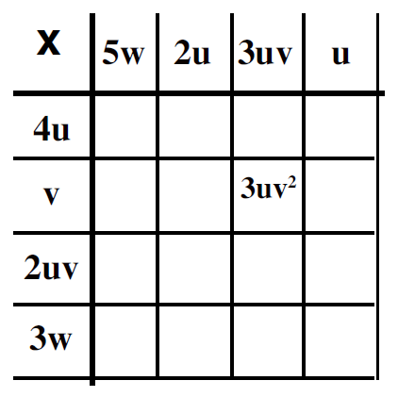
Checked

Core Skills 4
Dividing terms
1. 4a ÷ 2 =
2. 10x ÷ 5 =
3. 20y ÷ 4 =
4. 4f ÷ 4 =
5. 6g ÷ 3 =
6. 9p ÷ 3 =
7. 12x ÷ 4 =
8. 16y ÷ 8 =
9. 14a ÷ 7 =
10. 4x ÷ x =

Checked

Core Skills 5
Expanding brackets
1. 3(x + 2) =
2. 5(y - 3) =
3. 10(3x + 2) =
4. 4(2x + y) =
5. 5(3a + 5b) =
6. 6x(y – 2) =
7. 2a(3b + c) =
8. 3h(k – x) =
9. x(x + 1) =
10. a(ab + 2c) =

Checked

Solving 1
Solving 1 step equations
- 4x = 20 | 6. 14 = a + 3
- y + 5 = 8 | 7. 19 = b - 7
- a – 5 = 3 | 8. 90 = 10x
- $\frac{y}{4}=3$ | 9. $5=\frac{x}{3}$
- 4x = 36 | 10. 5 = 2x
Checked

Solving 2
Solving 2 step equations
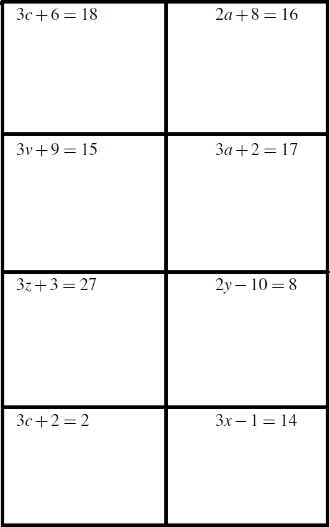
Checked
Solving 3
Expand and solve
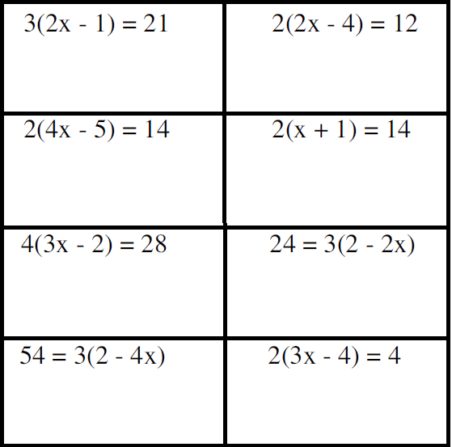
Checked
Solving 4
Simplify and solve
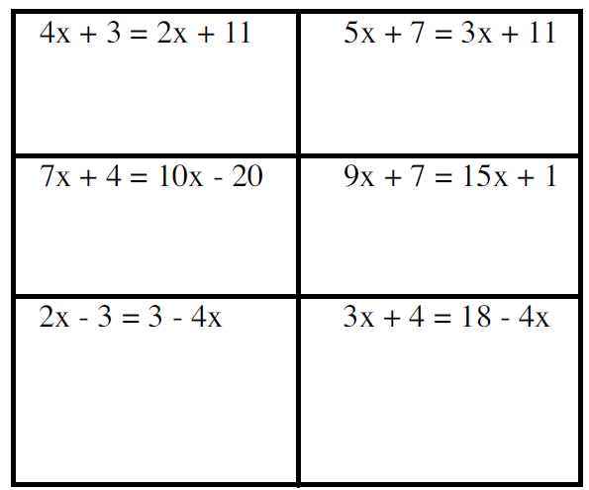
Checked

